**CTF Challenge: Scanning Website- Using Robtex**

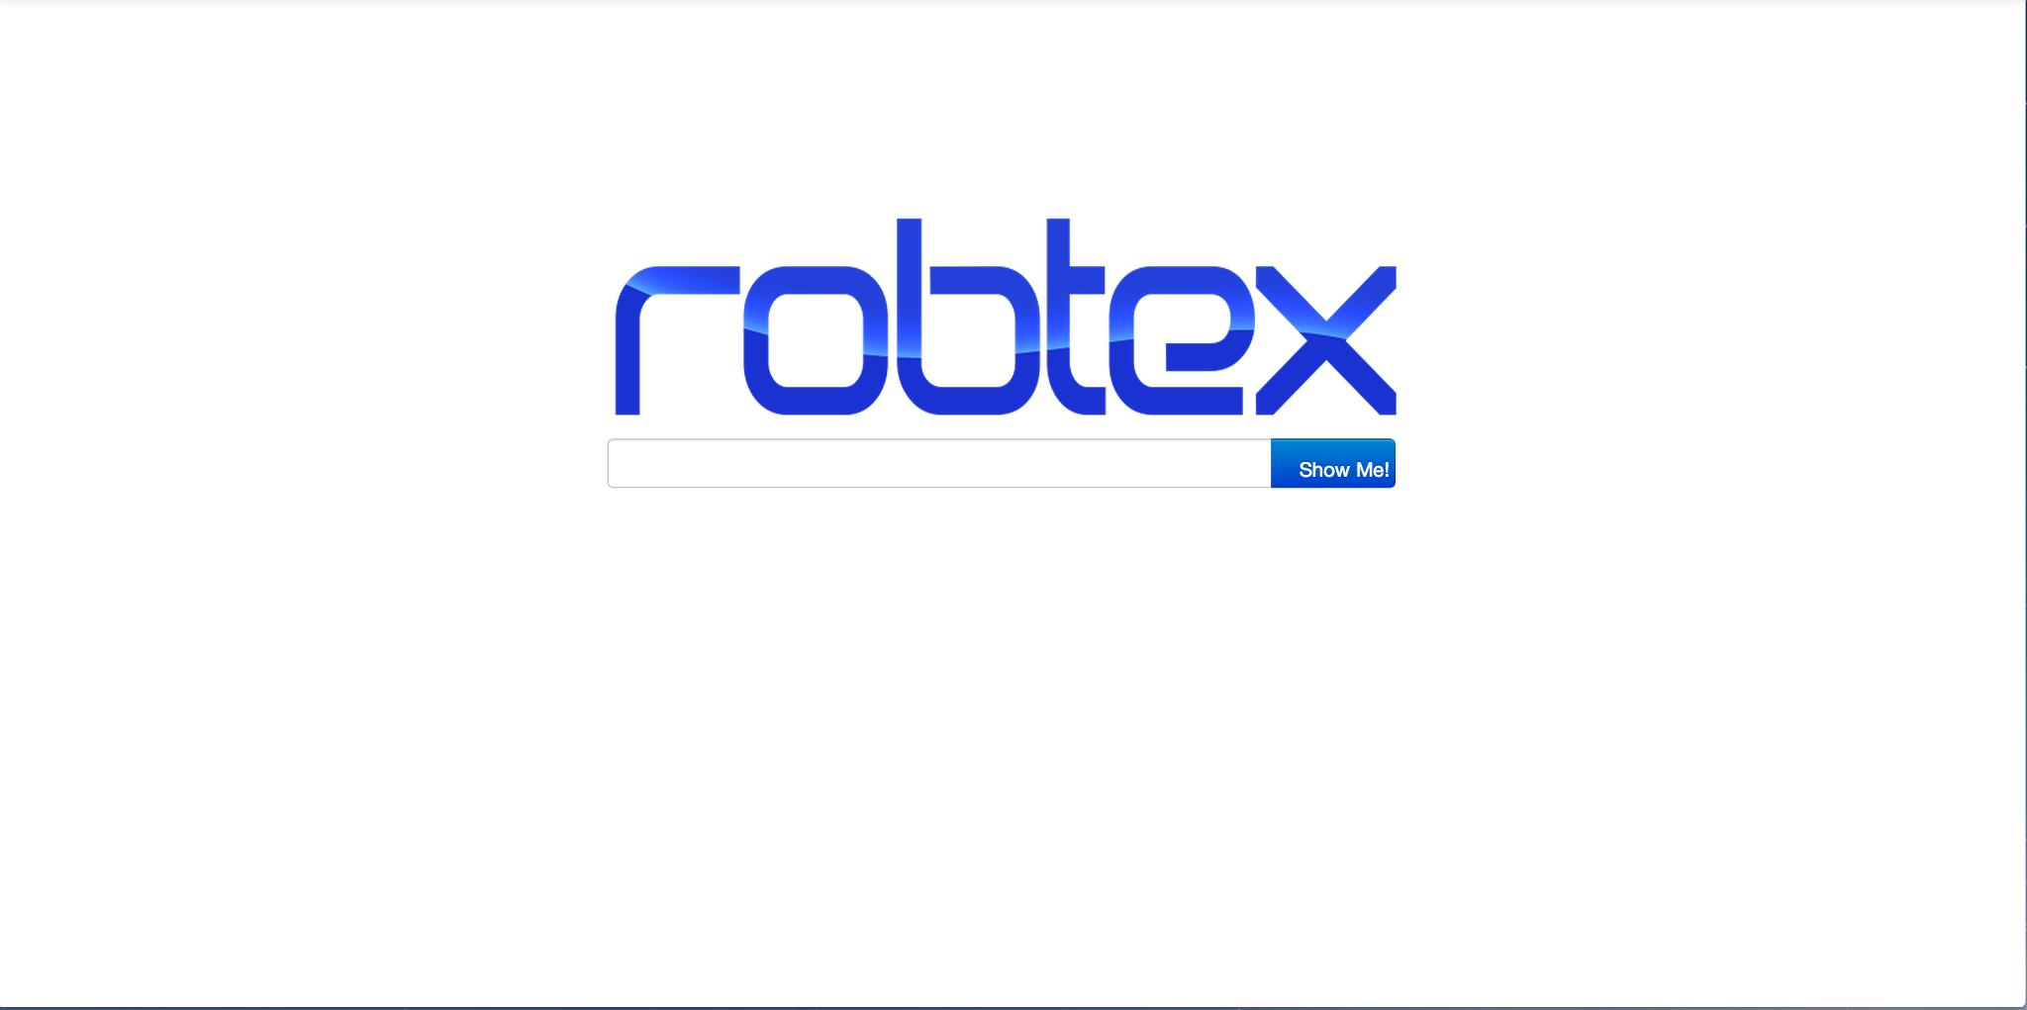

# **1. Introduction**

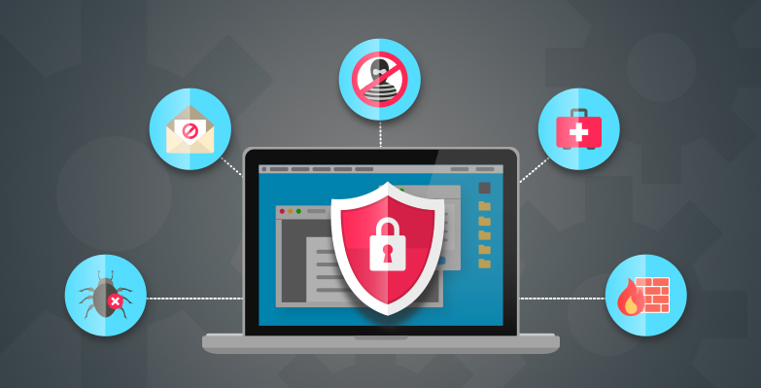

Robtex is an online tool that provides comprehensive information about IP addresses, domain names, and network infrastructure. This challenge will introduce you to using Robtex to gather information about a target domain.

# **2. Tools and requirements**

Access to the internet and Search for Robtex

# **3. Scenario**

You are an ethical hacker tasked with gathering information about a target domain using Robtex. Your job is to find the associated IP addresses and network details.

# **4. Process to follow while performing CTF**

Step 1: Go to your browser and click on [**https://www.robtex.com/**](https://www.robtex.com/)

Step 2: Enter the target domain name [**www.daraz.com**](http://www.daraz.com)into the search bar and perform the search.

Step 3: Solve the CTF.

# **5. Let’s Begin the Challenge**

Flag 1: What is the IP Address of the daraz?

Answer: 47.241.39.178

Flag Captured

Flag 2: How many IP does Daraz have?

Answer: One

Flag Captured

Flag 3: By which route is it hosted?

Answer: Proxy-registered route

Flag Captured

**Hint**

Use Robtex to perform a search for the target domain.

